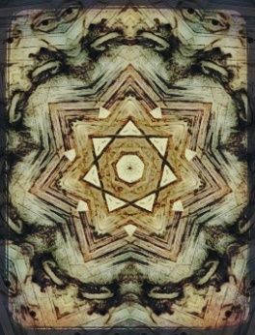  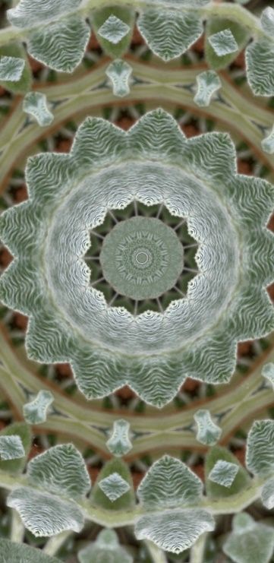  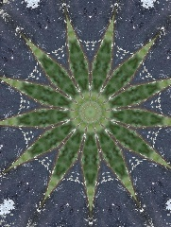  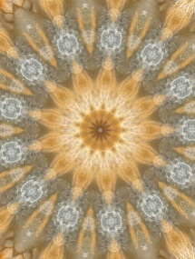 | and Black Lives Matter.  Wilder souls let nature thrive  under their enlightened guidance,  fostering a variety of species--  persimmons, prickly pears, roses,  violets, paw paws, burr oak,  red bud, goose-berry, red juniper,  and choirs of grasses and brush.  Old trees watch like shamans  along streets and alleys, in yards,  fence rows, dropping pollen, seeds,  leaves, broken branches onto polished  brick lanes. A few of these trees  are long-lived, wise in years, tomorrow  for age, size, rarity, and beauty.  They are consumed by their own affairs  and do not engage us until we put  them under threat and they put out  a spirit to touch us or some of us,  to save the endangered ones.  VI. Passage Beyond  Beyond the trees and lanes,  beyond the pace of the city,  the prairie extends and rolls,  and with it, my spirit ranges  across the expanse, lost  but not lost, beneath a sky  and a place to live our mutual city life,  as it lumbers into the future.  The poem I want to write  will be a banquet for every citizen.  I will spread out my tasty words,  cubed, marinated, perfectly cooked,  served with fresh intent and salty syntax.  And while you all dine as you will, this poem  will entertain your dreams and hopes.  Everywhere, twinkling lights,  soft June breezes in your hair,  a band playing music you love,  and you are there with your family,  your friends, your neighbors,  and everyone is happy, content,  no one is ugly, worried, angry,  or woeful. Urbana is at peace.  We marry, cry, wake, dance,  rise, live, build, imagine,  invent, love, and create  in this our Pretty Now Town.  We are proud to take part,  and when you hear this poem  I want to write for you here,  you may weep at your fortune  to live here among such folk.

